s4584569 Alev Akturk

1. 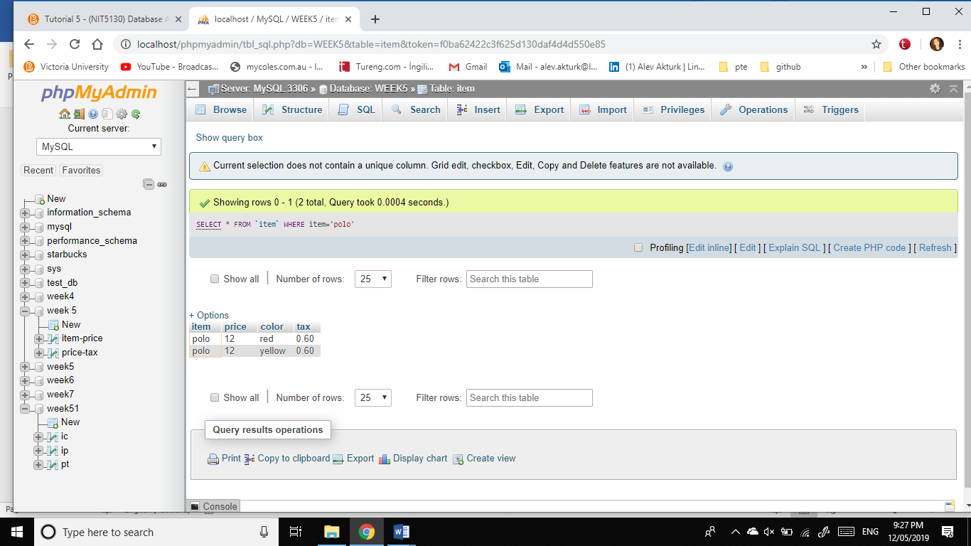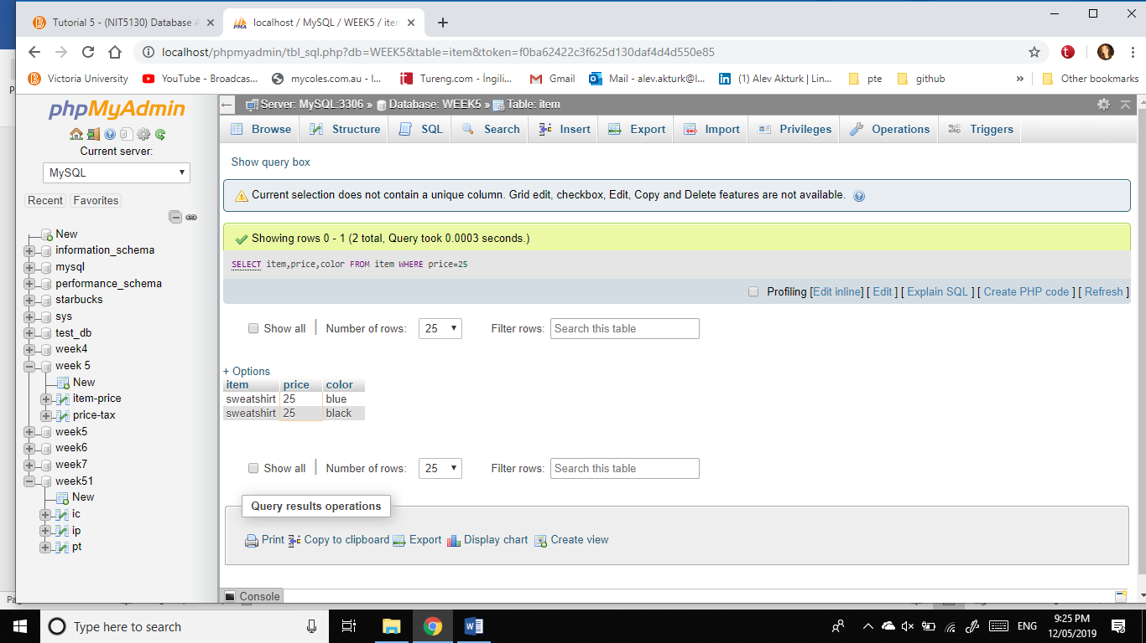List item, price and color of all items, whose price is 25  
   2. List all items, name, color price and tax. whose name is “polo”
2. List all item names “T-shirt” and “sweatshirt”, whose color is “blue” and “black”.

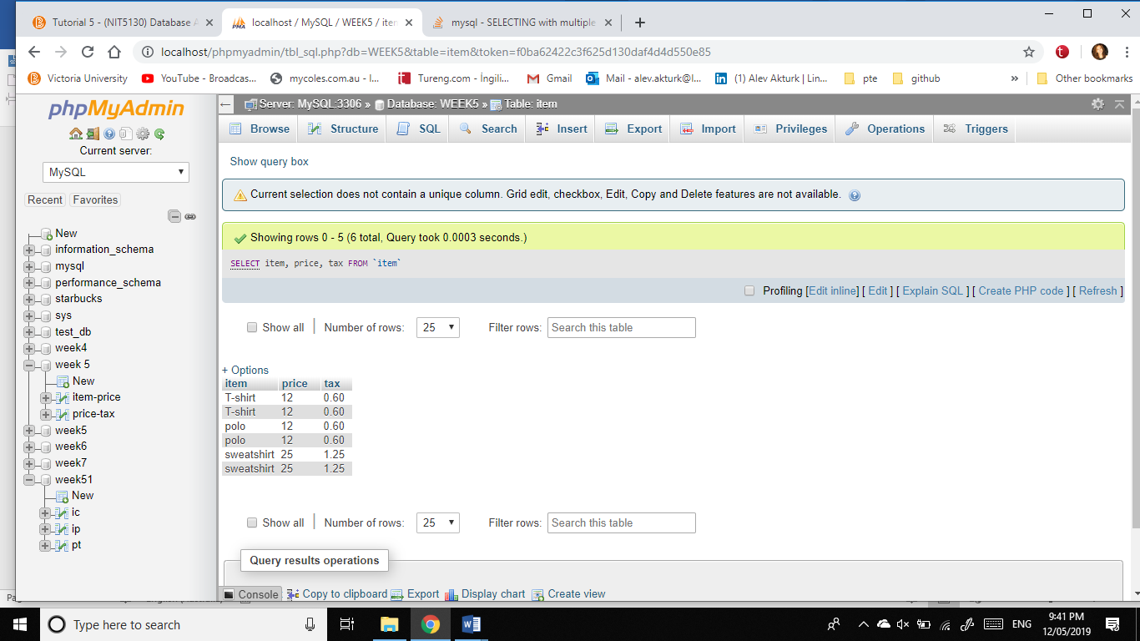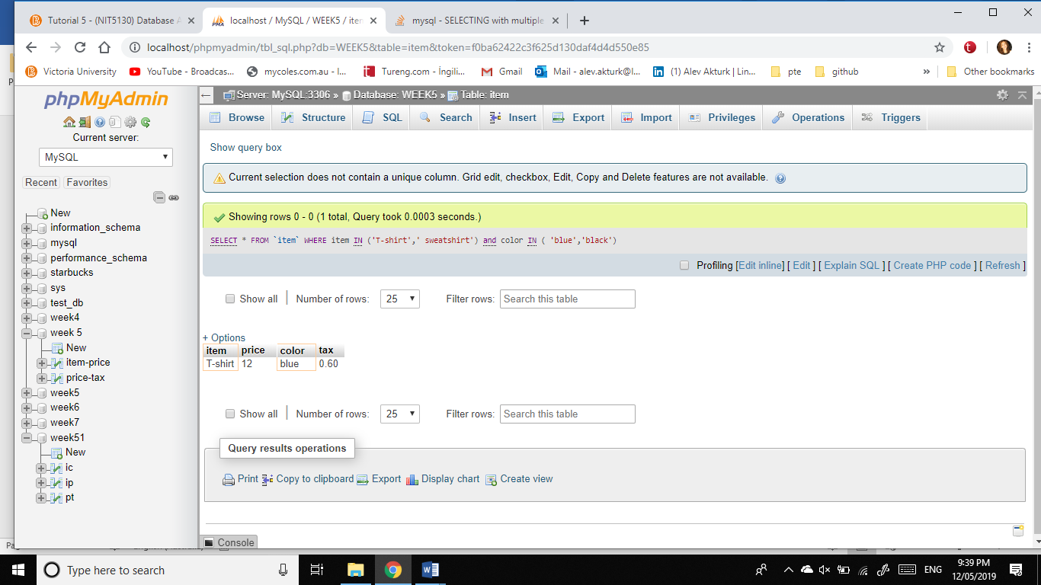There is no black T-Shirt so the result is one line.  
 4. List all item names, price and their tax.